1)

**AIM** :

Design Check board using HTML and CSS

**DESCRIPTION** :

* The background-image property specifies an image to use as the background of an element.
* By default, the image is repeated so it covers the entire element.
* color property is used to set the color of the element.
* The CSS border properties allow you to specify the style, width, and color of an element's border.
* The border-width property specifies the width of the four borders.
* The width can be set as a specific size (in px, pt, cm, em, etc) or by using one of the three pre-defined values: thin, medium, or thick
* The border-color property is used to set the color of the four borders.
* The CSS height and width properties are used to set the height and width of an element.

**PROGRAM CODE** :

**chessboard.html**

<!DOCTYPE html>

<html lang="en">

<head>

<meta charset="UTF-8">

<meta http-equiv="X-UA-Compatible" content="IE=edge">

<meta name="viewport" content="width=device-width, initial-scale=1.0">

<link rel="stylesheet" href="style.css">

<title>Chess Board</title>

</head>

<body>

<table cellpadding=40 cellspacing=3 border=2 align="center">

<tr>

<td>&#9820;</td>

<td class="black">&#9822;</td>

<td>&#9821;</td>

<td class="black">&#9819;</td>

<td>&#9818;</td>

<td class="black">&#9821;</td>

<td>&#9822;</td>

<td class="black">&#9820;</td>

</tr>

<tr>

<td class="black">&#9823;</td>

<td>&#9823;</td>

<td class="black">&#9823;</td>

<td>&#9823;</td>

<td class="black">&#9823;</td>

<td>&#9823;</td>

<td class="black">&#9823;</td>

<td>&#9823;</td>

</tr>

<tr>

<td></td>

<td class="black"></td>

<td></td>

<td class="black"></td>

<td></td>

<td class="black"></td>

<td></td>

<td class="black"></td>

</tr>

<tr>

<td class="black"></td>

<td></td>

<td class="black"></td>

<td></td>

<td class="black"></td>

<td></td>

<td class="black"></td>

<td></td>

</tr>

<tr>

<td></td>

<td class="black"></td>

<td></td>

<td class="black"></td>

<td></td>

<td class="black"></td>

<td></td>

<td class="black"></td>

</tr>

<tr>

<td class="black"></td>

<td></td>

<td class="black"></td>

<td></td>

<td class="black"></td>

<td></td>

<td class="black"></td>

<td></td>

</tr>

<tr>

<td>&#9817;</td>

<td class="black">&#9817;</td>

<td>&#9817;</td>

<td class="black">&#9817;</td>

<td>&#9817;</td>

<td class="black">&#9817;</td>

<td>&#9817;</td>

<td class="black">&#9817;</td>

</tr>

<tr>

<td class="black">&#9814;</td>

<td>&#9816;</td>

<td class="black">&#9815;</td>

<td>&#9813;</td>

<td class="black">&#9812;</td>

<td>&#9815;</td>

<td class="black">&#9816;</td>

<td>&#9814;</td>

</tr>

</table>

</body>

</html>

**style.css**

body{

background-image: linear-gradient(to right,rgb(177, 164, 164) , white);

}

table{

border : 10px solid green;

}

.black{

background-color: black;

}

td{

color:blue;

font-size: 25px;

height: 25px;

}

OUTPUT :

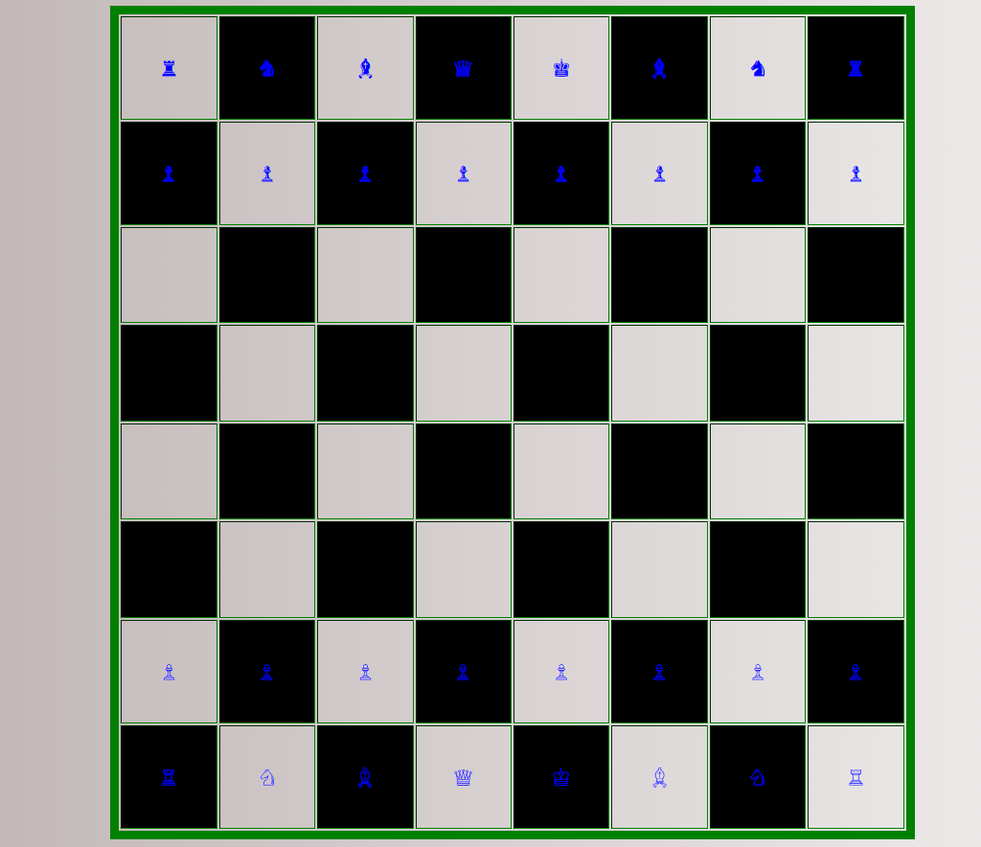

**RESULT ANALYSIS** :

<table> has been used to create the chessboard.

Classes has been used for coloring the background.

border property has been used to set the size, style and color of the border.

Character entities of html has been used to place the coins on the chessboard.

2)

**AIM** :

Create below html page using frames

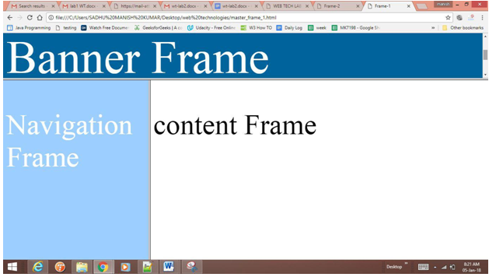

**DESCRIPTION** :

* HTML <frame> tag define the particular area within an HTML file where another HTML web page can be displayed.
* A <frame> tag is used with <frameset>, and it divides a webpage into multiple sections or frames, and each frame can contain different web pages.
* If you want to use frames in a web browser instead of the <body> tag, you can put the <frameset> tag. It defines the structure of a frame (zone in the browser window, where we can load another web page), the number of columns and rows, and also how many percent/pixels it will occupy in a frame.
* The CSS margin properties are used to create space around elements, outside of any defined borders.
* The CSS padding properties are used to generate space around an element's content, inside of any defined borders.
* The HTML <marquee> tag defines a scrolling text area in the HTML document that moves across the page in a horizontal or vertical direction

**PROGRAM CODE** :

**index.html**

<!DOCTYPE html>

<html lang="en">

<head>

<meta charset="UTF-8">

<meta http-equiv="X-UA-Compatible" content="IE=edge">

<meta name="viewport" content="width=device-width, initial-scale=1.0">

<title>Document</title>

<link rel="stylesheet" href="frame.css">

</head>

<body>

<iframe class="a" src="top.html"></iframe>

<iframe name="left" class="b" src="frame.html"></iframe>

<iframe name="right" class="c" src=""></iframe>

</body>

</html>

**frame.html**

<!DOCTYPE html>

<html lang="en">

<head>

<meta charset="UTF-8" />

<meta http-equiv="X-UA-Compatible" content="IE=edge" />

<meta name="viewport" content="width=device-width, initial-scale=1.0" />

<title>Document</title>

<style>

ul {

list-style-type: none;

margin: 0;

padding: 0;

width: 280px;

background-color: #f1f1f1;

}

li a {

display: block;

color: #000;

padding: 25px 25px;

text-decoration: none;

}

/* Change the link color on hover */

li a:hover {

background-color: #555;

color: white;

}

a:focus {

background-color: #555;

color: white;

}

</style>

</head>

<body>

<ul>

<li><a href="firstpage.html" target="right" class="active">Home</a></li>

<li>

<a href="Week 1/timetable.html" target="right">Class Time Table</a>

</li>

<li><a href="Week 1/menucard.html" target="right">Menu Card</a></li>

<li><a href="Week 1/biodata.html" target="right">My Biodata</a></li>

<li><a href="Week 1/tablebio.html" target="right">Table Bio</a></li>

<li><a href="chessboard.html" target="right">Chess Board</a></li>

<li>

<a href="Reg Form/usingtable.html" target="right">Registration form</a>

</li>

</ul>

</body>

</html>

**top.html**

<!DOCTYPE html>

<html lang="en">

<head>

<meta charset="UTF-8">

<meta http-equiv="X-UA-Compatible" content="IE=edge">

<meta name="viewport" content="width=device-width, initial-scale=1.0">

<title>Document</title>

<link rel="preconnect" href="https://fonts.googleapis.com">

<link rel="preconnect" href="https://fonts.gstatic.com" crossorigin>

<link href="https://fonts.googleapis.com/css2?family=Grape+Nuts&family=Red+Hat+Mono:ital,wght@1,300&family=Rubik:ital,wght@1,300&display=swap" rel="stylesheet">

<style>

body{

background-image: linear-gradient(to right,rgb(187, 179, 179),white);

font-family:'Grape Nuts', cursive;

}

p{

font-size: 30px;

text-align: center;

}

</style>

</head>

<body>

<p><marquee>Usage of Frames</marquee></p>

</body>

</html>

**frame.css**

.a{

/* border:2px solid red; */

width: 100%;

height:100px;

}

.b{

/* border:2px solid blue; */

width: 24%;

height: 500px;

}

.c{

/* border:2px solid green; */

width: 75%;

height: 500px;

}

OUTPUT :

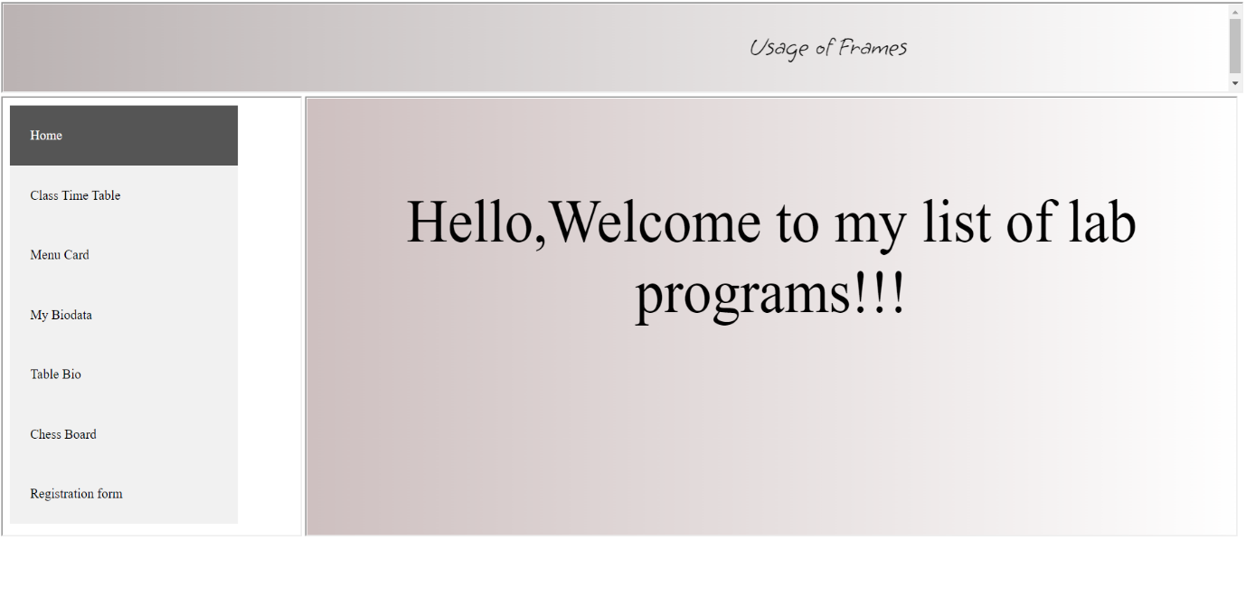

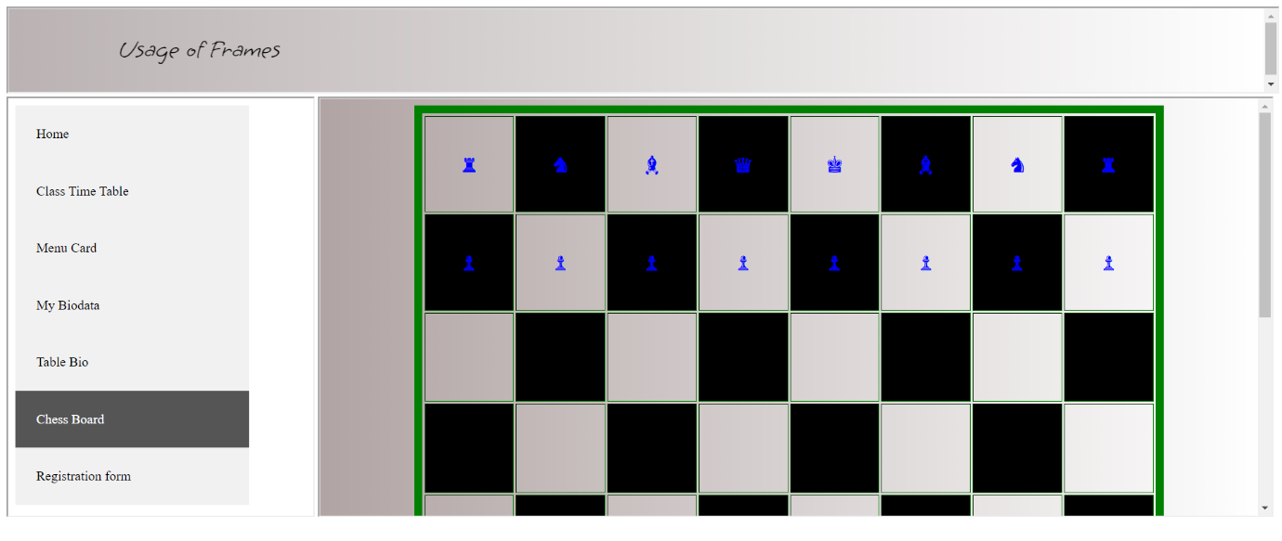

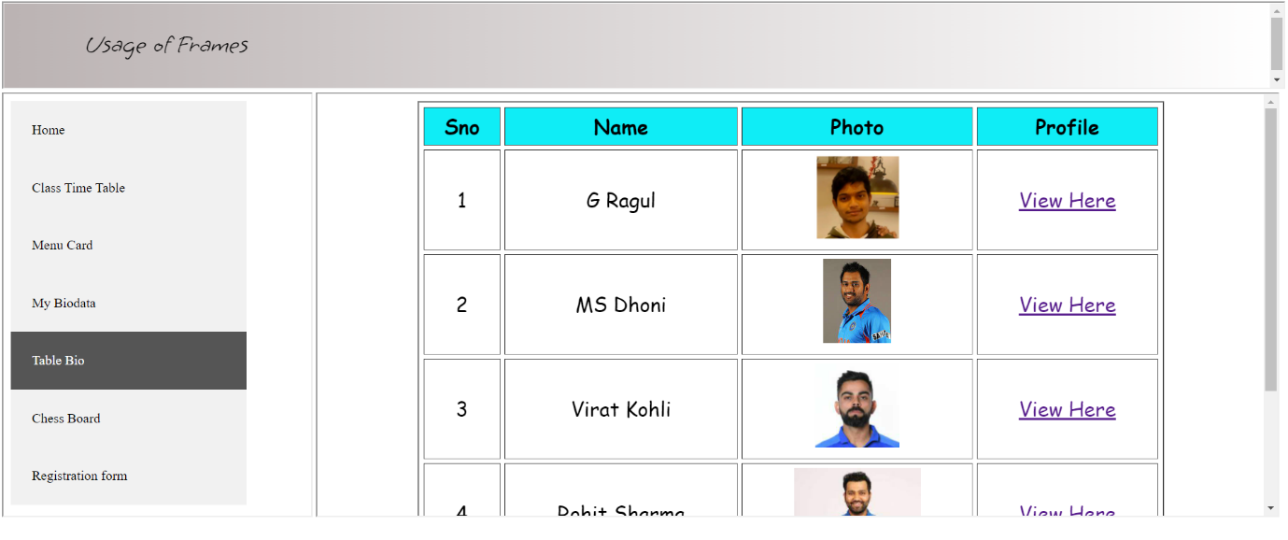

**RESULT ANALYSIS** :

<iframe> tag has been used to create various sections in the web page.

name attribute of the <iframe> and target attribute of <a> are given same value so that when the link is clicked the web page would get displayed on the right pane.

frame.html displays the vertical nav bar.

3)

**AIM** :

Design a student Educational portal using HTML and CSS.

**DESCRIPTION** :

* The CSS margin properties are used to create space around elements, outside of any defined borders.
* The CSS padding properties are used to generate space around an element's content, inside of any defined borders.
* The CSS border properties allow you to specify the style, width, and color of an element's border.
* The CSS margin properties are used to create space around elements, outside of any defined borders.
* With CSS, you have full control over the margins. There are properties for setting the margin for each side of an element (top, right, bottom, and left).

**PROGRAM CODE** :

**index.html**

<!DOCTYPE html>

<html lang="en">

<head>

<meta charset="UTF-8">

<meta http-equiv="X-UA-Compatible" content="IE=edge">

<meta name="viewport" content="width=device-width, initial-scale=1.0">

<title>Document</title>

<link rel="stylesheet" href="style.css">

</head>

<body>

<div class="navbar">

<ul>

<li><a href="home.html" target="hello">Home</a></li>

<li><a href="https://learning.cbit.org.in/" target="hello">LMS</a></li>

<li><a href="https://erp.cbit.org.in/beeserp/login.aspx" target="hello">ERP</a></li>

<li><a href="Reg Form/usingtable.html" target="hello">Login</a></li>

<li><a href="https://www.cbit.ac.in/about_post/about/" target="hello">About</a></li>

<li><input type="text" placeholder="Search" ></li>

</ul>

</div>

<div class="try">

<iframe name="hello" class="lms"></iframe>

</div>

</body>

</html>

**home.html**

<!DOCTYPE html>

<html lang="en">

<head>

<meta charset="UTF-8" />

<meta http-equiv="X-UA-Compatible" content="IE=edge" />

<meta name="viewport" content="width=device-width, initial-scale=1.0" />

<title>Document</title>

<link rel="preconnect" href="https://fonts.googleapis.com" />

<link rel="preconnect" href="https://fonts.gstatic.com" crossorigin />

<link

href="https://fonts.googleapis.com/css2?family=Courgette&family=Quicksand:wght@300&family=Red+Hat+Display:wght@300&display=swap"

rel="stylesheet"

/>

<style>

body {

font-family: "Courgette", cursive;

font-family: "Quicksand", sans-serif;

font-family: "Red Hat Display", sans-serif;

}

.image {

/* border: 2px solid red; */

width: 100%;

height: 230px;

color: white;

/* background-image: linear-gradient(rgba(85, 133, 231, 0.5), white); */

}

.container-a {

display: inline-block;

/* border: 2px solid red; */

width: 30%;

height: 250px;

margin-top: 10px;

margin: 10px;

color: white;

/* background-size: cover; */

padding: 4px;

float: left;

}

.container-b {

display: inline-block;

/* border: 2px solid red; */

width: 30%;

height: 250px;

margin: 10px;

color: white;

padding: 4px;

float: left;

}

.container-c {

display: inline-block;

/* border: 2px solid red;*/

width: 32%;

height: 250px;

margin: 10px;

padding: 4px;

float: left;

color: white;

}

img {

float: left;

margin: 10px;

}

</style>

</head>

<body>

<div class="image">

<img src="school.jfif" />

<h1>Welcome to CBIT</h1>

Chaitanya Bharathi Institute of Technology (CBIT) is a private engineering

college located in Gandipet, near Financial District, Hyderabad,

Telangana, India. The college is affiliated to Osmania University and is

accredited by the National Board of Accreditation. The institute received

an autonomous status in 2013.CBIT is located at Gandipet near Financial

District in Hyderabad. The campus is 25 km from Secunderabad Railway

Station and 28 km from Rajiv Gandhi International Airport. It is well

connected with radial roads and outer ring road (ORR) for an easy access

by road. With a total of 12 blocks in the campus, eight blocks are

assigned to ECE, EEE, CSE, IT, Mechanical, Mechanical (Production), Civil,

Chemical, Bio-Tech, MBA, and MCA departments. Four blocks are for the

library, R&D, physical education department (sports), cafeteria, and

assembly halls. Workshop sheds and laboratories are found between the

blocks.

</div>

<div class="container-a">

<strong>History</strong><br />

CBIT was established in 1979.[4] The institute is affiliated to Osmania

University, originally with three undergraduate programs and an intake of

200 students. By 2014 this had grown to nine undergraduate and seven

postgraduate courses with a total intake of 9000 students . It was

inaugurated by late Dr. Marri Chenna Reddy. CBIT is the first private

engineering college in Telangana. One of the milestones for the college

was when its students were part of the team involved in the design and

successful launch of a satellite, STUDSAT, with the Indian Space Research

Organisation. STUDSAT was successfully placed in orbit and received the

first signal on 12 July 2010 at 11:07 AM IST.

</div>

<div class="container-b">

<strong>Overview</strong><br />

Chaitanya Bharathi Institute of Technology (CBIT) is a private engineering

college located in Gandipet, near Financial District, Hyderabad,

Telangana, India. The college is affiliated to Osmania University[1] and

is accredited by the National Board of Accreditation.[2] The institute

received an autonomous status in 2013.[3]

</div>

<div class="container-c">

<strong>Course Admissions</strong><br />

The college admits undergraduates and postgraduates. Undergraduate

students are admitted through the statewide EAMCET examination conducted

for intermediate students and TS ECET conducted for Diploma students.

Postgraduate students through GATE and ICET, which are conducted every

year. Apart from EAMCET, GATE, and ICET exams, students are also admitted

through B-Category (selection based on IITJEE, AIEEE, EAMCET ranks) and

NRI quota.

</div>

</body>

</html>

**success.html**

<!DOCTYPE html>

<html lang="en">

<head>

<meta charset="UTF-8">

<meta http-equiv="X-UA-Compatible" content="IE=edge">

<meta name="viewport" content="width=device-width, initial-scale=1.0">

<title>Document</title>

</head>

<body>

<h1>Form successfully submitted!!!</h1>

</body>

</html>

style.css

body{

background-image: url("data:image/svg+xml,%3csvg xmlns='http://www.w3.org/2000/svg' version='1.1' xmlns:xlink='http://www.w3.org/1999/xlink' xmlns:svgjs='http://svgjs.com/svgjs' width='1440' height='560' preserveAspectRatio='none' viewBox='0 0 1440 560'%3e%3cg mask='url(%26quot%3b%23SvgjsMask1012%26quot%3b)' fill='none'%3e%3crect width='1440' height='560' x='0' y='0' fill='%230e2a47'%3e%3c/rect%3e%3cpath d='M705.67%2c346.754C746.534%2c348.991%2c791.749%2c337.862%2c811.012%2c301.754C829.594%2c266.922%2c807.962%2c227.444%2c787.247%2c193.836C767.926%2c162.491%2c742.465%2c132.248%2c705.67%2c130.852C666.832%2c129.379%2c631.17%2c153.059%2c612.621%2c187.213C594.859%2c219.919%2c599.825%2c259.068%2c618.575%2c291.218C637.167%2c323.096%2c668.822%2c344.737%2c705.67%2c346.754' fill='rgba(28%2c 83%2c 142%2c 0.4)' class='triangle-float1'%3e%3c/path%3e%3cpath d='M999.208%2c386.647C1042.158%2c383.8%2c1073.884%2c352.53%2c1096.929%2c316.174C1122.348%2c276.073%2c1149.724%2c227.678%2c1126.066%2c186.513C1102.366%2c145.276%2c1046.759%2c145.097%2c999.208%2c146.142C954.153%2c147.132%2c906.645%2c154.384%2c881.653%2c191.885C854.107%2c233.218%2c850.475%2c288.282%2c876.142%2c330.807C901.092%2c372.143%2c951.032%2c389.84%2c999.208%2c386.647' fill='rgba(28%2c 83%2c 142%2c 0.4)' class='triangle-float1'%3e%3c/path%3e%3cpath d='M291.231%2c339.692C342.487%2c343.087%2c399.319%2c331.116%2c424.819%2c286.524C450.198%2c242.142%2c429.18%2c188.766%2c402.462%2c145.177C377.247%2c104.039%2c339.475%2c67.77%2c291.231%2c68.577C244.04%2c69.366%2c208.2%2c107.004%2c186.261%2c148.793C166.024%2c187.34%2c164.165%2c232.498%2c185.142%2c270.647C206.931%2c310.273%2c246.108%2c336.703%2c291.231%2c339.692' fill='rgba(28%2c 83%2c 142%2c 0.4)' class='triangle-float2'%3e%3c/path%3e%3cpath d='M1333.179%2c134.457C1349.353%2c134.551%2c1364.153%2c124.849%2c1371.578%2c110.48C1378.47%2c97.142%2c1374.975%2c81.51%2c1367.162%2c68.69C1359.713%2c56.469%2c1347.486%2c47.846%2c1333.179%2c47.478C1318.213%2c47.093%2c1303.745%2c54.032%2c1296.028%2c66.861C1288.076%2c80.08%2c1288.114%2c96.519%2c1295.544%2c110.039C1303.264%2c124.085%2c1317.151%2c134.364%2c1333.179%2c134.457' fill='rgba(28%2c 83%2c 142%2c 0.4)' class='triangle-float2'%3e%3c/path%3e%3cpath d='M1239.557%2c162.343C1275.032%2c160.289%2c1296.675%2c127.222%2c1313.676%2c96.019C1329.696%2c66.616%2c1342.42%2c32.495%2c1326.293%2c3.15C1309.711%2c-27.023%2c1273.97%2c-39.889%2c1239.557%2c-38.849C1207.008%2c-37.866%2c1178.761%2c-19.45%2c1161.449%2c8.131C1142.791%2c37.856%2c1133.054%2c74.252%2c1148.912%2c105.561C1166.179%2c139.652%2c1201.407%2c164.552%2c1239.557%2c162.343' fill='rgba(28%2c 83%2c 142%2c 0.4)' class='triangle-float2'%3e%3c/path%3e%3cpath d='M1183.1835160207875 351.0011714172133L1211.447675203674 511.2951835378974 1371.741687324358 483.0310243550109 1343.4775281414716 322.7370122343268z' fill='rgba(28%2c 83%2c 142%2c 0.4)' class='triangle-float3'%3e%3c/path%3e%3cpath d='M1141.9032817030732 285.34737086770576L1213.230440305359 227.58777669840674 1155.4708461360601 156.26061809612077 1084.143687533774 214.0202122654198z' fill='rgba(28%2c 83%2c 142%2c 0.4)' class='triangle-float1'%3e%3c/path%3e%3cpath d='M637.37 102.49 a142.93 142.93 0 1 0 285.86 0 a142.93 142.93 0 1 0 -285.86 0z' fill='rgba(28%2c 83%2c 142%2c 0.4)' class='triangle-float1'%3e%3c/path%3e%3c/g%3e%3cdefs%3e%3cmask id='SvgjsMask1012'%3e%3crect width='1440' height='560' fill='white'%3e%3c/rect%3e%3c/mask%3e%3cstyle%3e %40keyframes float1 %7b 0%25%7btransform: translate(0%2c 0)%7d 50%25%7btransform: translate(-10px%2c 0)%7d 100%25%7btransform: translate(0%2c 0)%7d %7d .triangle-float1 %7b animation: float1 5s infinite%3b %7d %40keyframes float2 %7b 0%25%7btransform: translate(0%2c 0)%7d 50%25%7btransform: translate(-5px%2c -5px)%7d 100%25%7btransform: translate(0%2c 0)%7d %7d .triangle-float2 %7b animation: float2 4s infinite%3b %7d %40keyframes float3 %7b 0%25%7btransform: translate(0%2c 0)%7d 50%25%7btransform: translate(0%2c -10px)%7d 100%25%7btransform: translate(0%2c 0)%7d %7d .triangle-float3 %7b animation: float3 6s infinite%3b %7d %3c/style%3e%3c/defs%3e%3c/svg%3e");

opacity: 0.9;

}

li a:focus{

background-color: #04AA6D;

}

.lms {

/* border: 2px solid red; */

width: 100%;

height: 600px;

margin-right: 10px;

margin-top:10px;

}

ul {

list-style-type: none;

margin: 0;

padding: 0;

overflow: hidden;

background-color: #333;

}

li {

float: left;

}

li a {

display: block;

color: white;

text-align: center;

padding: 14px 16px;

text-decoration: none;

}

li input{

display: block;

color: white;

margin-top:12px;

margin-left: 10px;

text-decoration: none;

}

/* Change the link color to #111 (black) on hover */

li a:hover {

background-color: #04AA6D;

}

**OUTPUT** :



**RESULT ANALYSIS** :

* Using the navigation bar we are able to link to different web pages.
* Using the display property we are able to convert an element from block to inline and inline to block respectively.